**Q-1 Create a class ‘Bank’ comprises of data like bank_id, bank_name, brance_name and create another class ‘Account’ which holds data like ac_no, ac_name, ac_type (saving/current), and balance. Create another class ‘Transaction’ which holds the functions to perform following operations:**

**1. Create New Account**

**2. Deposit & Withdraw (Min 500 balance) in particular**

**3. List out details of only those accounts whose type is ‘current’.**

**Source Code :**

#include <iostream.h>

#include <conio.h>

#include <string.h>

class bank

{

int b_id;

char b_name[10], b_bname[10];

public:

void get_new()

{

cout<<"ENTER BANK ID:- ";

cin>>b_id;

cout<<"ENTER THE BANK NAME:- ";

cin>>b_name;

cout<<"ENTER THE BANK BRANCE:- ";

cin>>b_bname;

}

void display_bank()

{

cout<<"\nBANK ID:- "<<b_id;

cout<<"\nBANK NAME:- "<<b_name;

cout<<"\nBANK BRANCE:- "<<b_bname;

}

};

class account

{

int ac_no;

char ac_name[13];

public:

char ac_type;

float ac_bal;

void get_ac()

{

cout<<"\nENTER A/C NO:- ";

cin>>ac_no;

cout<<"ENTER A/C NAME:- ";

cin>>ac_name;

cout<<"ENTER (C-CURRENT OR S-SAVING) A/C:- ";

cin>>ac_type;

cout<<"ENTER A/C BALANCE:- ";

cin>>ac_bal;

}

void display_ac()

{

cout<<"\nA/C NO:- "<<ac_no;

cout<<"\nA/C NAME:- "<<ac_name;

cout<<"\nA/C TYPE:- "<<ac_type;

cout<<"\nA/C BAL:- "<<ac_bal;

}

};

class transaction:public bank,public account

{

public:

float wd;

int s;

public:

void create()

{

get_new();

get_ac();

}

void dep_wit()

{

cout<<"ENTER 1 FOR DEPOSIT AND 2 FOR WITHDRAW \n";

cin>>s;

if(s==1)

{

cout<<"ENTER AMOUNT FOR DEPOSIT:- ";

cin>>wd;

ac_bal=ac_bal+wd;

}

else if(s==2)

{

cout<<"ENTER AMOUNT FOR WITHDRAW:- ";

cin>>wd;

if(wd>ac_bal)

{

cout<<"insufficient bal";

}

else

{

ac_bal=ac_bal-wd;

}

}

cout<<"A/C BAL:- "<<ac_bal;

}

void current_details()

{

if(ac_type=='c' || ac_type=='C')

{

cout<<"\n****CURRENT DETAILS****";

display_bank();

display_ac();

}

else

{

cout<<"\nthere is only saving A/C";

}

}

};

void main()

{

clrscr();

transaction a;

a.create();

a.dep_wit();

a.current_details();

getch();

}

OUTPUT:-

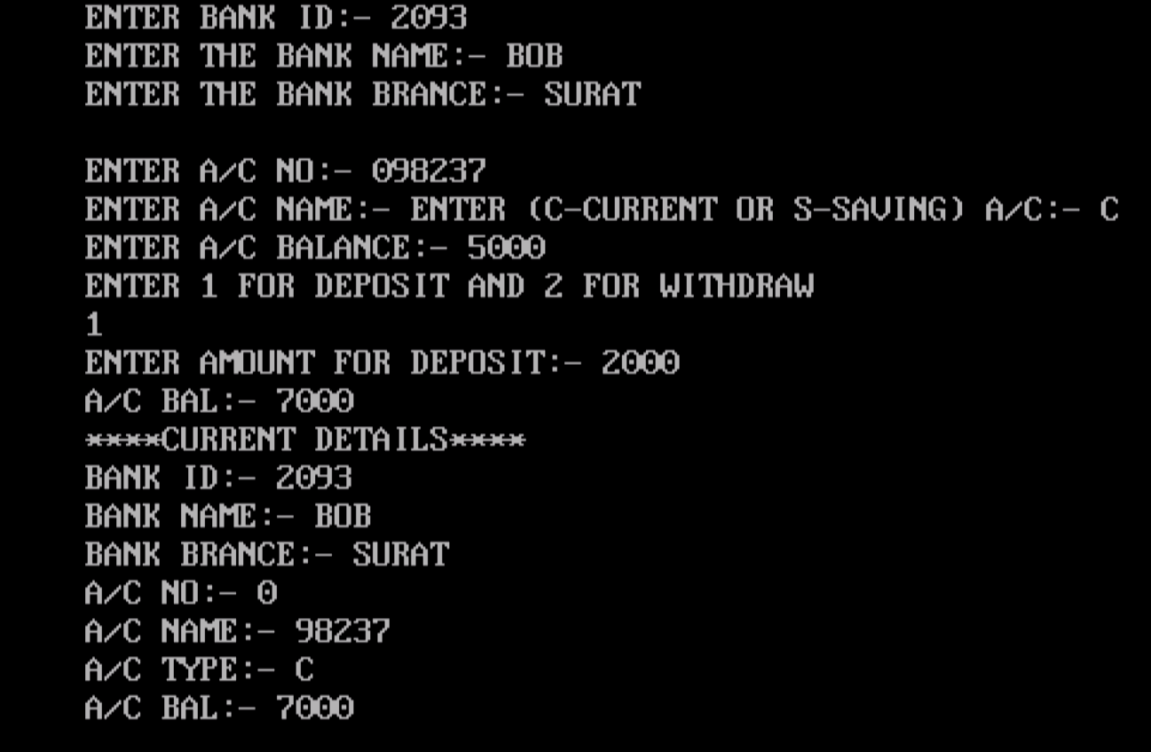

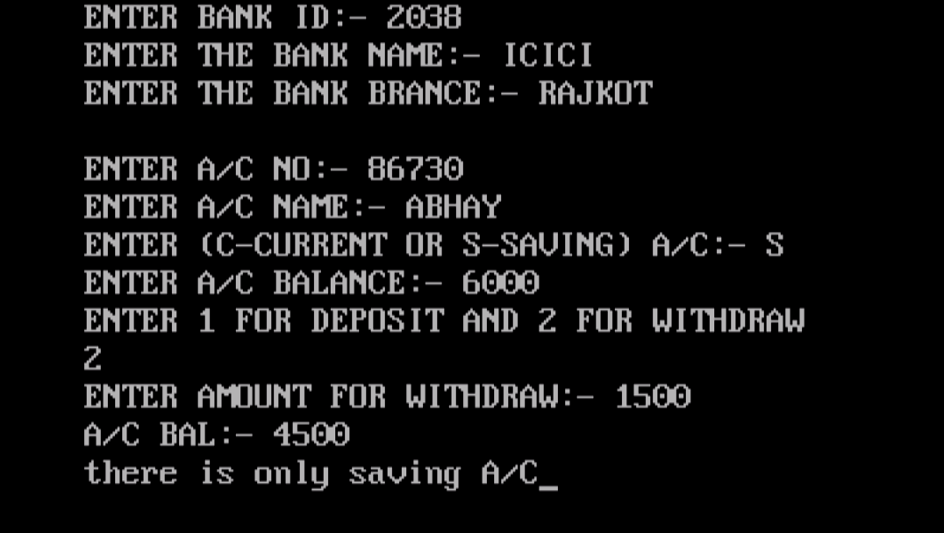

**Q-2 Create a class “ word ”which stores a string value. Overload +, == for concatenation and comparison operation respectively.**

**Source Code :**

#include<iostream.h>

#include<conio.h>

#include<string.h>

class word

{

char a[20],b[20];

public:

void get()

{

cout<<"enter first string:"<<endl;

cin>>a;

cout<<"enter second string:"<<endl;

cin>>b;

}

void operator +()

{

cout<<"***concatenation***"<<endl;

cout<<a<<" "<<b<<endl;

}

void operator = (word)

{

cout<<"***comparison***"<<endl;

if(strcmp(a,b)==0)

{

cout<<"equal";

}

else

{

cout<<"not equal";

}

}

};

void main()

{

clrscr();

word s;

s.get();

+s;

s=(s);

getch();

}

OUTPUT:-

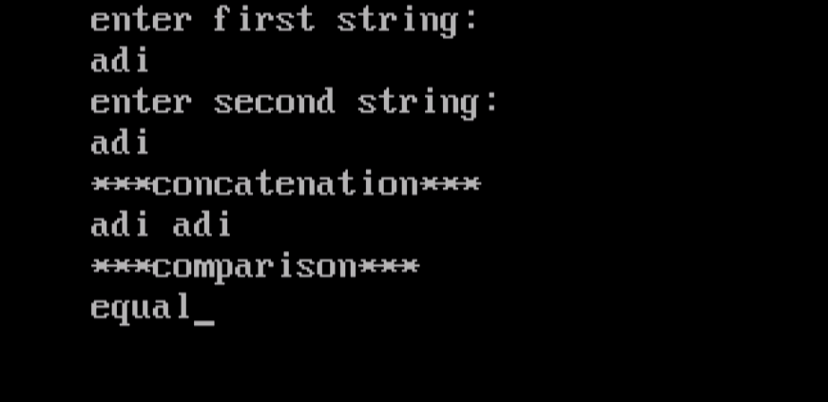

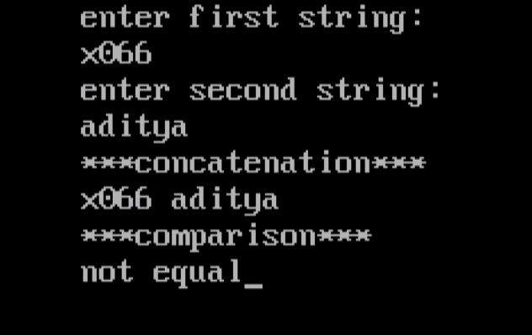

**Q-3 Create class using multilevel inheritance of student list**

**1 st class contain roll no and name of student**

**2 nd class contain marks of three subject**

**3 rd class contain total and percentage Input data of at least 5 student and display all the information in proper format.**

**Source Code :**

#include<iostream.h>

#include<conio.h>

class student

{

int roll_no;

char name[15];

public:

void get_stud()

{

cout<<"Enter rollno:- "<<endl;

cin>>roll_no;

cout<<"Enter name:- "<<endl;

cin>>name;

}

void dis_stud()

{

cout<<"Roll_no:- "<<roll_no<<endl;

cout<<"Name:- "<<name<<endl;

}

};

class marks:public student

{

public:

int sub[3];

void get_marks()

{

int i;

for(i=0;i<3;i++)

{

cout<<"\nEnter marks of sub"<<i+1<<":- ";

cin>>sub[i];

}

}

void dis_marks()

{

int j;

cout<<"\n* * * * subject marks * * * *"<<endl;

for(j=0;j<3;j++)

{

cout<<"sub"<<j+1<<":- "<<sub[j]<<endl;

}

}

};

class total:public marks

{

int total;

float per;

public:

total()

{

total=0;

}

void get_total()

{

cout<<"\n* * * student detail * * *"<<endl;

int i;

for(i=0;i<3;i++)

{

total=total+sub[i];

}

per=total*100/300;

}

void dis_total()

{

dis_stud();

dis_marks();

cout<<"\n total:- "<<total<<"/300"<<endl;

cout<<"percentage:- "<<per<<endl;

}

};

void main()

{

clrscr();

total s;

s.get_stud();

s.get_marks();

s.get_total();

s.dis_total();

getch();

OUTPUT:-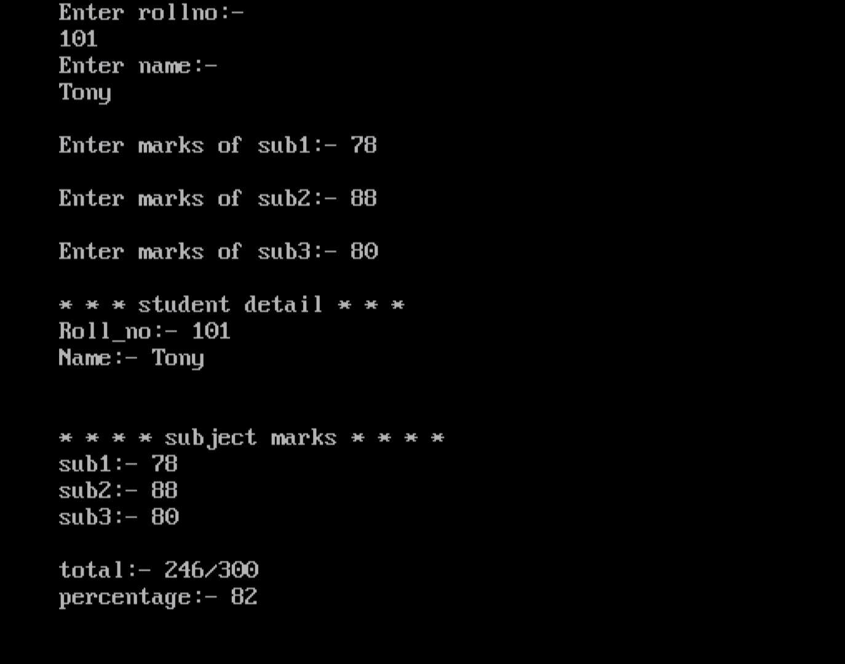

**Q-4 Create a book class (bookid,bookname,year,publication) & student class (rollno,name,year,books). Display list of books borrowed by student from library.**

**Source Code :**

#include<iostream.h>

#include<conio.h>

class book

{

int book_id , t b_year;

char book_name[20], pub[30];

public:

void get_book()

{

cout<<"Enter book id:- ";

cin>>book_id;

cout<<"Enter book name:- ";

cin>>book_name;

cout<<"Enter year:- ";

cin>>b_year;

cout<<"Enter publication name:- ";

cin>>pub;

}

};

class student:public book

{

int roll_no, year;

char name[15], s_book[15];

public:

void get_student()

{

cout<<"****Student detail****"<<endl;

cout<<"Enter roll no:- ";

cin>>roll_no;

cout<<"Enter student nane:- ";

cin>>name;

cout<<"year:- ";

cin>>year;

cout<<"Enter book name to borrowed:- ";

cin>>s_book;

}

void b_book()

{

cout<<"***Book Borrowed by student***"<<endl;

cout<<s_book;

}

};

void main()

{

clrscr();

student s;

s.get_book();

s.get_student();

s.b_book();

getch();

}

OUTPUT:-

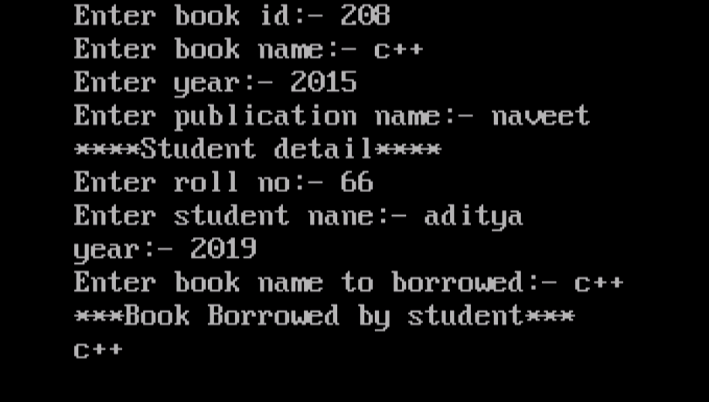

**Q-5 Create an event class, create dynamic objects of event class and release the memory of the created object before program terminates.**

**Source Code:**

#include<iostream.h>

#include<conio.h>

class event

{

int a[10],n;

public:

event()

{

cout<<"Enter number of value to be entered: ";

cin>>n;

cout<<"constructor is called..."<<endl;

for(int i=0;i<n;i++)

{

cout<<"enter the value of a["<<i+1<<"]:- ";

cin>>a[i];

}

}

void dis()

{

for(int i=0;i<n;i++)

{

cout<<"a["<<i+1<<"];- "<<a[i]<<endl;

}

}

~event()

{

cout<<"destructor is called"<<endl;

}

};

void main()

{

clrscr();

event e;

e.dis();

getch();

}

OUTPUT:-

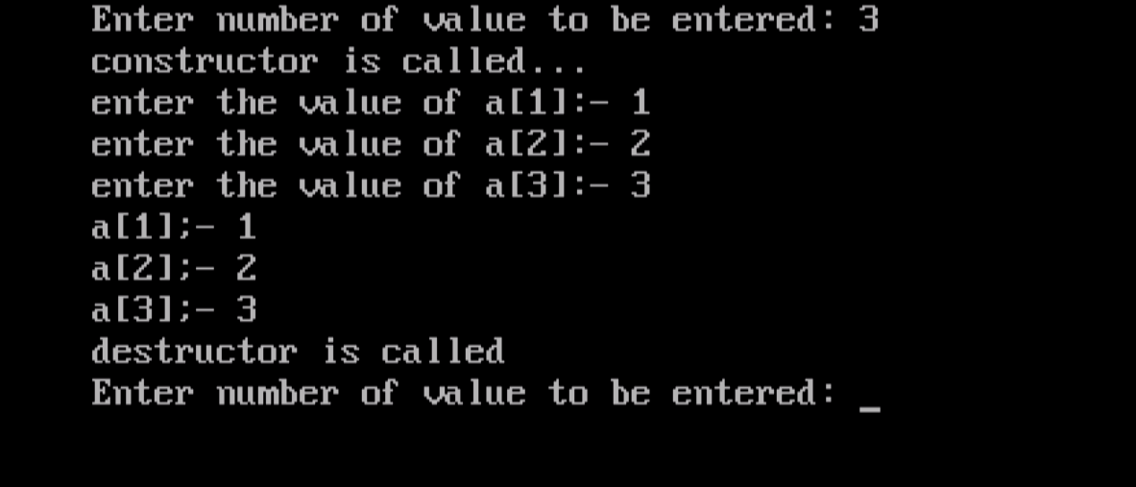

**Q-6 Create a program to implement stack with its operations**

**Source Code :**

#include<iostream.h>

#include<conio.h>

class stack

{

int a[10], top;

public:

stack()

{

top=0;

}

void push(int);

void pop();

void disp();

};

void stack::push(int l)

{

if(top==4)

{

cout<<"stack is full";

}

else

{

a[top]=l;

top++;

}

}

void stack::pop()

{

if(top==0)

{

cout<<"stack is empty"<<endl;

}

else

{

a[top]=0;

top--;

}

}

void stack::disp()

{

int i;

cout<<"*****stack*****"<<endl;

for(i=top-1;i>=0;i--)

{

cout<<a[i]<<endl;

}

}

void main()

{

clrscr();

stack s;

s.push(1);

s.push(2);

s.push(3);

s.push(4);

s.disp();

s.pop();

s.push(5);

s.disp();

getch();

}

OUTPUT:

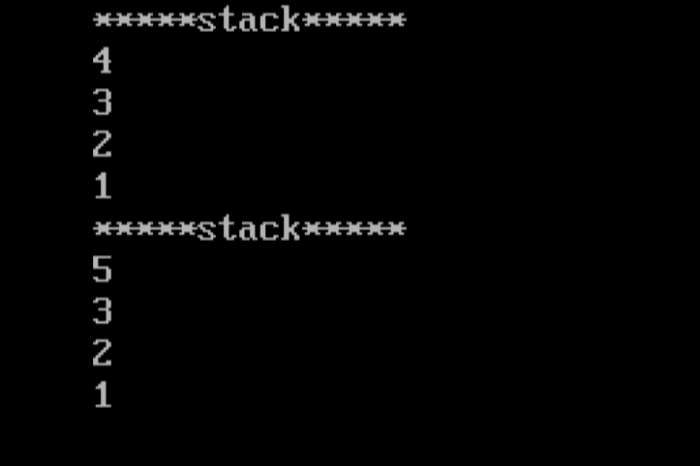

**Q-7 Create a program to implement infix to postfix conversion.**

**Source Code :**

#include<iostream.h>

#include<string>

#define MAX 20

char stk[20];

int top=-1;

void push(char oper)

{

if(top==MAX-1)

{

cout<<"stackfull!!!!";

}

else

{

top++;

stk[top]=oper;

}

}

char pop()

{

char ch;

if(top==-1)

{

cout<<"stackempty!!!!";

}

else

{

ch=stk[top];

stk[top]='\0';

top--;

return(ch);

}

return 0;

}

int priority ( char alpha )

{

if(alpha == '+' || alpha =='-')

{

return(1);

}

if(alpha == '*' || alpha =='/')

{

return(2);

}

if(alpha == '$')

{

return(3);

}

return 0;

}

string convert(string infix)

{

int i=0;

string postfix = "";

while(infix[i]!='\0')

{

if(infix[i]>='a' && infix[i]<='z'|| infix[i]>='A'&& infix[i]<='Z')

{

postfix.insert(postfix.end(),infix[i]);

i++;

}

else if(infix[i]=='(' || infix[i]=='{' || infix[i]=='[')

{

push(infix[i]);

i++;

}

else if(infix[i]==')' || infix[i]=='}' || infix[i]==']')

{

if(infix[i]==')')

{

while(stk[top]!='(')

{ postfix.insert(postfix.end(),pop());

}

pop();

i++;

}

if(infix[i]==']')

{

while(stk[top]!='[')

{

postfix.insert(postfix.end(),pop());

}

pop();

i++;

}

if(infix[i]=='}')

{

while(stk[top]!='{')

{

postfix.insert(postfix.end(),pop());

}

pop();

i++;

}

}

else

{

if(top==-1)

{

push(infix[i]);

i++;

}

else if( priority(infix[i]) <= priority(stk[top])) {

postfix.insert(postfix.end(),pop());

while(priority(stk[top]) == priority(infix[i])){

postfix.insert(postfix.end(),pop());

if(top < 0) {

break;

}

}

push(infix[i]);

i++;

}

else if(priority(infix[i]) > priority(stk[top])) {

push(infix[i]);

i++;

}

}

}

while(top!=-1)

{

postfix.insert(postfix.end(),pop());

}

cout<<"The converted postfix string is : "<<postfix; //it will print postfix conversion

return postfix;

}

int main()

{

int cont;

string infix, postfix;

cout<<"\nEnter the infix expression : "; //enter the expression

cin>>infix;

postfix = convert(infix);

return 0;

}

Output:

Enter the infix expression : a=b*2+5

The converted postfix string is : ab*=+25

**Q-8 Create a program to implement simple queue with its operations.**

**Source Code :**

#include<iostream.h>

class Queue {

public:

int front, rear, size;

unsigned capacity;

int* array;

};

Queue* createQueue(unsigned capacity)

{

Queue* queue = new Queue();

queue->capacity = capacity;

queue->front = queue->size = 0;

queue->rear = capacity - 1;

queue->array = new int[queue->capacity];

return queue;

}

int isFull(Queue* queue)

{

return (queue->size == queue->capacity);

}

int isEmpty(Queue* queue)

{

return (queue->size == 0);

}

void enqueue(Queue* queue, int item)

{

if (isFull(queue))

return;

queue->rear = (queue->rear + 1)

% queue->capacity;

queue->array[queue->rear] = item;

queue->size = queue->size + 1;

cout << item << " enqueued to queue\n";

}

int dequeue(Queue* queue)

{

if (isEmpty(queue))

return INT_MIN;

int item = queue->array[queue->front];

queue->front = (queue->front + 1)

% queue->capacity;

queue->size = queue->size - 1;

return item;

}

int front(Queue* queue)

{

if (isEmpty(queue))

return INT_MIN;

return queue->array[queue->front];

}

int rear(Queue* queue)

{

if (isEmpty(queue))

return INT_MIN;

return queue->array[queue->rear];

}

int main()

{

Queue* queue = createQueue(1000);

enqueue(queue, 10);

enqueue(queue, 20);

enqueue(queue, 30);

enqueue(queue, 40);

cout << dequeue(queue)

<< " dequeued from queue\n";

cout << "Front item is "

<< front(queue) << endl;

cout << "Rear item is "

<< rear(queue) << endl;

return 0;

}

Output:

10 enqueued to queue

20 enqueued to queue

30 enqueued to queue

40 enqueued to queue

10 dequeued from queue

Front item is 20.